# A Proposal Presentation on The RFID Based Vehicle Monitoring System

# by

# *Yash Patel, Mabel Nachaki, Latei Moses and Edgar Moturi*

## Introduction.

### Abstract.

The current system used at the weighbridges at the Kenyan Highways is the ANPR system. On a survey, we noticed that the system was unable to capture the number plates for some of the vehicles which in turn reduced its effectiveness to its major role. This is a drawback since the operators had to manually check in for any vehicle that wasn’t properly identified aided by the photos that were taken by the ANPR cameras which gets tedious as time goes by depending on the traffic. Moreover, forgery of number plates renders ANPR cameras less effective, thus the RFID system will be using UHF; that will be broadcasted dependent on the area of view which can be unidirectional, bi-directional and omni-directional. First, a UHF reader/writer will be used to embed vehicle details on an RFID tag, then the tag will be stuck on the windshield of the vehicle. Then a UHF RFID long range integrated reader will be installed on the desired places on the road where tracking is deemed necessary. And when a vehicle that has the tag on it, is in the reading range of the RFID reader, the data on the windshield tag will be fetched, then channeled through an appropriate protocol to a correspondent database then displayed upon request that will be done by the appropriate user. This will improve the general aim of latest technologies being employed in our modern roads.

### Abbreviations And Key Terms.

ANPR- Automatic Number Plate Recognition - An AI based framework that uses various image scanning technologies in order to capture the number plate of a vehicle

RFID- Radio Frequency Identification- A technology that uses Radio Waves for identifying tags that have unique IDs.

.

UHF- Ultra High Frequency- This refers to the frequency range that is used by the RFID reader. It indicates that the RFID is of a high range radius

### Importance of RFID Based System

1. RFID tags last for a long time of around 5-7 years
2. It reduces the possibility of the vehicle not being recognized
3. The range of UHF RFID reader is around 5-25m depending on the transmitter and antenna
4. The speed of read is around 700 tags per second which makes sure that most tags if not all are read by the system.

### Objectives

#### Main Objectives

1. To curb the problem of shrewd drivers and/or transporters who knowingly change the number plate of the vehicle.
2. To note down number plates that may have been left out from scanning by the ANPR cameras.

#### Specific Objectives

1. To develop an RFID based system that is able to scan tags from vehicles
2. To program vehicle details into RFID tags for verification.

## Literature review

Contact for this section!...

## System Requirements and Structure.

Following are the related product specifications:



The reader writer will be used by the administrators who will be managing tag entries and any issue related.

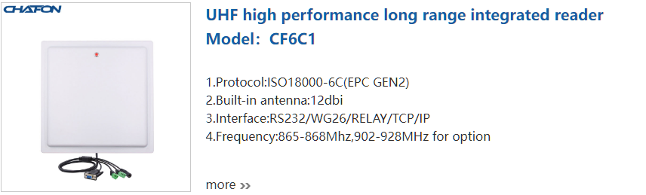

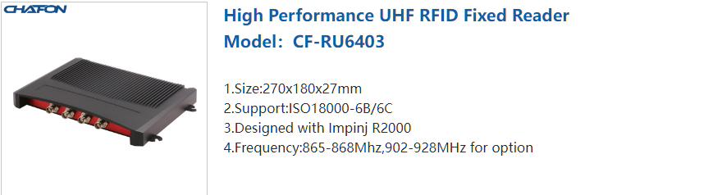

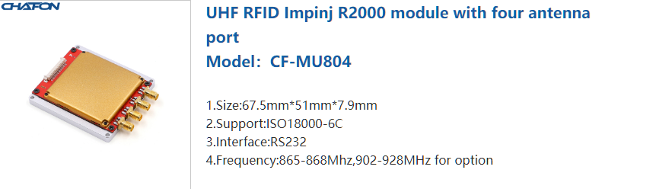

A choice between the three will be installed on the roads to monitor tag movements.

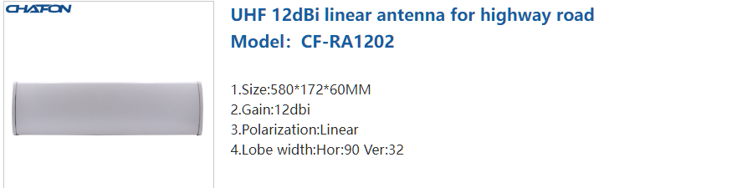

This will be attached to the fixed reader module thus exposing it to the area of coverage

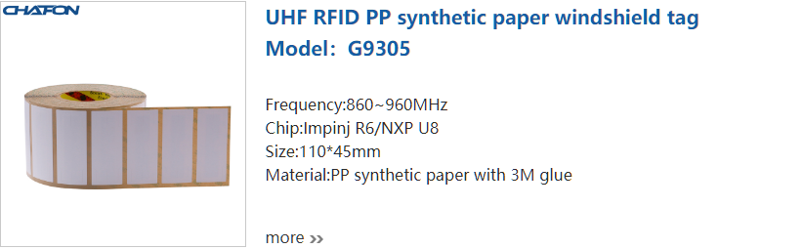

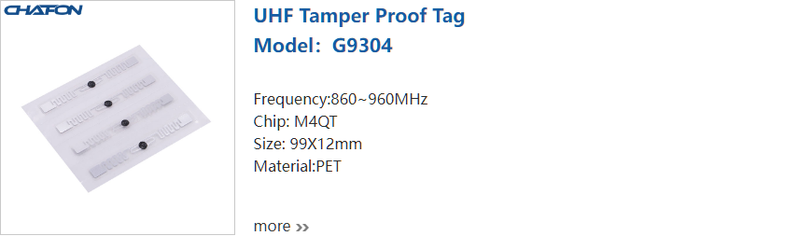

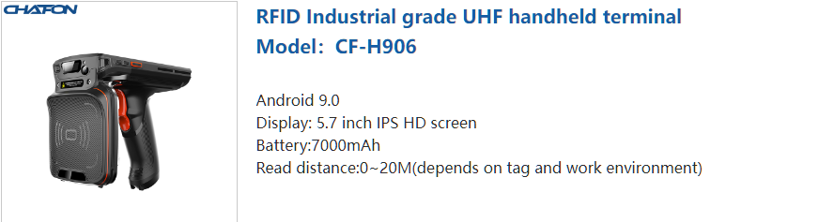

To be deployed to the traffic cops or instance for pending vehicle mis-formalities.

## Requirements of the RFID based vehicle recognition

1. RFID transmitter
2. Rfid antenna
3. RFID windshield tag
4. Imitation Vehicles for testing
5. RFID reader/writer
6. Handheld RFID tag reader.

### Budget Analysis.

The favorable product supplier and commodity price is as follows:

|  | **Chafon** |  |  | **Zebra** |
| --- | --- | --- | --- | --- |
| Usb rfid reader/writer | Actual: 4,210 |  | RFID Reader Fixed FX 9600 8ports | Price: $1,981 |
| Shipping: 200 |  | Kshs: **235,110** |
| **Total Cost**: Kshs 4,410 |  | Zebra AN480 (LHCP) RFID Antenna (865-956 MHz) | Price: $214.46 |
| 100 pieces long range RFID tag sticker | Actual: 1,350 |  | Kshs: **25,520** |
| Shipping:170 |  | 35 Ft Cable | Price: $152 |
| **Total Cost**: Kshs 1,520 |  | Kshs: **18,050** |
| 5-6M uhf RFID reader 6db: RS232, WG 26 ethernet(optional) | Actual: 11,050 |  | Zebra RFD40 Standard UHF RFID Sled | Price: $1,249.00 |
| Shipping: 33,600 |  | Kshs: **148,250** |
| **Total Cost**: Kshs 44,650 |  | ZT 411 RFID printer (Usb, serial, ethernet, Bluetooth) | Price: $3,213 |
| 10M tcp/Ip uhf rfid reader RS232, WG26 | Actual: 17,950 |  | Kshs. **382,000** |
| Shipping: 45,400 |  | RFID label for labels | Price: $204 |
| **Total Cost**: Kshs 64,350 |  | Kshs. **24,220** |
| R3000 fixed rfid reader 4 ports RS232, RJ45 | Actual:35,250 |  | Standard industrial wax resin ribbon | Price: $206 |
| Shipping: 37,520 |  | Kshs. **24,500** |
| **Total Cost**: Kshs 72,770 |  |  |  |
| Integrated uhf long range reader 12dbi circular RS232, RS485, RJ45 | Actual: 17,250 |  |  |  |
| Shipping: 81,620 |  |  |  |
| **Total Cost**: Kshs 98,870 |  |  |  |
| **Grand Total** | Kshs **286,570** |  | **Grand Total** | Kshs: **857,650** |

**Chafon RFID**

| **Advantages** | **Disadvantages** |
| --- | --- |
| Cheap to Acquire | Unclear SDK (mostly in Chinese) |
| Uses ISO18000-6B | No API endpoint for web socket |
| Integrates both the antenna and the transmitter | Proprietary protocols used thus making it difficult to program |
| Supports PoE |  |

**Zebra RFID**

| **Advantages** | **Disadvantages** |
| --- | --- |
| Uses ISO18000-6B | Expensive to acquire |
| Has a web socket endpoint |  |
| Supports PoE |  |

## Working Principles

The Radio Frequency Identification system will work on a high-speed radio frequency generated by the system readers installed at a located point which will capture vehicle details from the tags embedded on the windshields and thereafter transmits the data obtained to a server via a Transport and Control Protocol versus an Internet Protocol to a server which will then transfer it to databases or data analysis from the centralized place. Through a web based graphical user interface to the system operators, the enforcement units and the Kenha officers in charge, the data in the databases will be decrypted and displayed upon user demand all in real time. With the system having distributed capability allows transmission of live data allowing the users of the system for appropriate actions.

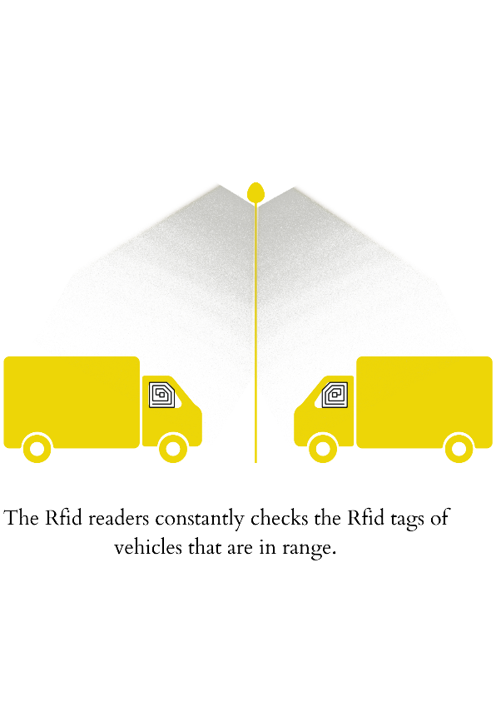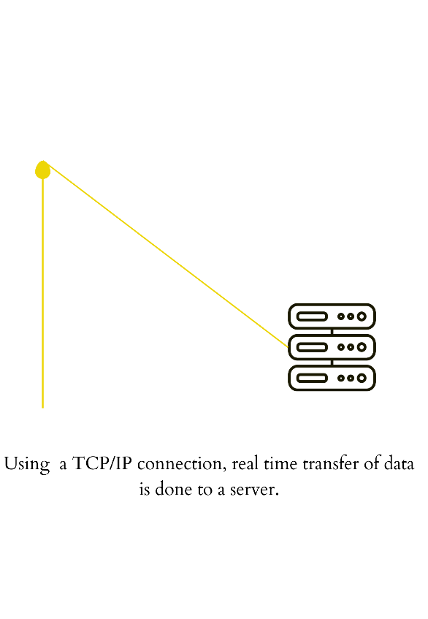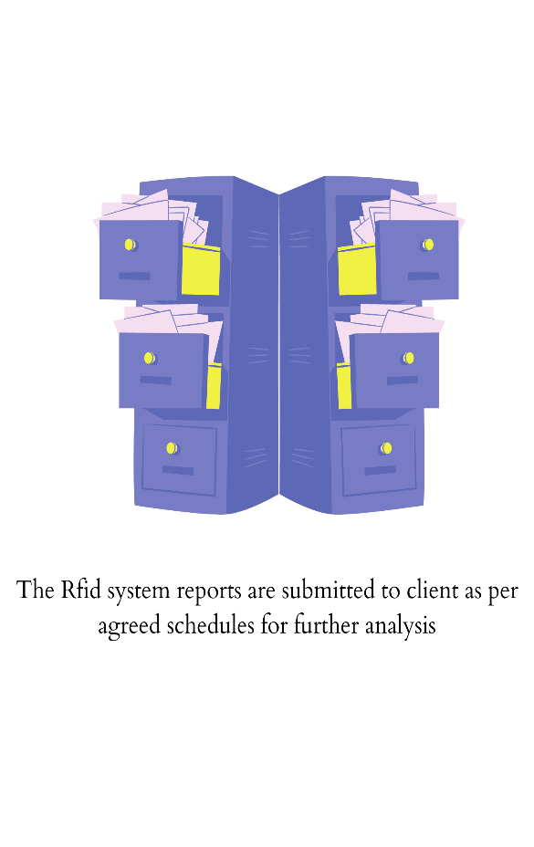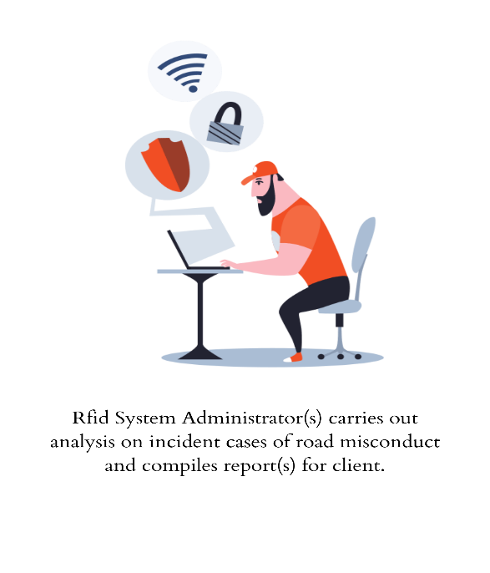

## Application Architecture

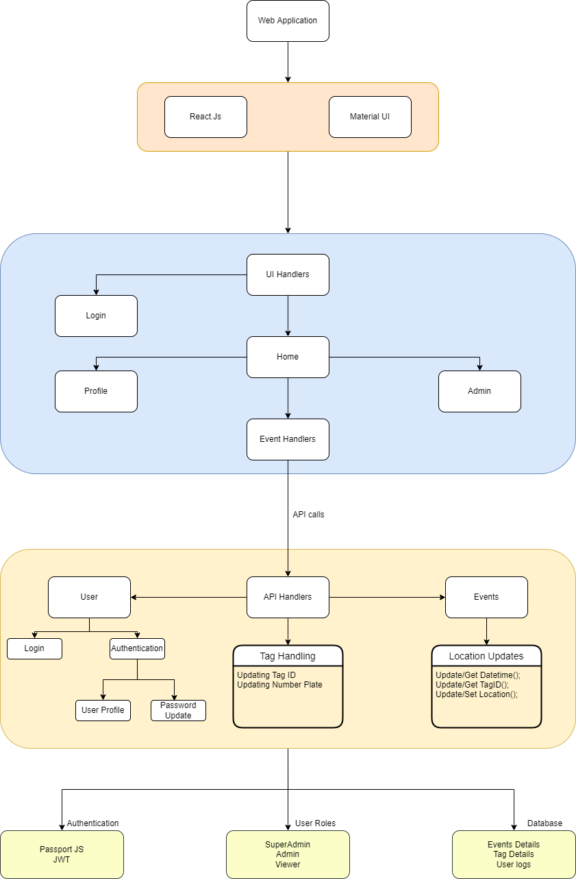

## Future Works.

1. Integration with insurance stickers to tag and remind vehicle owners or drivers of expired insurance
2. Installing the RFID readers in town and improving the system such that it tracks vehicles on most of the locations which makes it easier to track down cases such as trafficking and theft.
3. Creating a mobile app and adding a QR code at the back of the sticker such that in case of an accident, help may be dispatched to the location of accident reported.

## References.

Contact for this section!...